UNITED STATES
SECURITIES AND EXCHANGE COMMISSION
Washington, DC 20549
SCHEDULE 14A INFORMATION
Proxy Statement Pursuant to Section 14(a) of
the Securities Exchange Act of 1934 (Amendment No. )
Filed by the Registrant ☒
Filed by a Party other than the Registrant ☐
Check the appropriate box:

☐ |  | Preliminary Proxy Statement
☐ |  | Confidential, for Use of the Commission Only (as permitted by Rule 14a-6(e)(2))
☐ |  | Definitive Proxy Statement
☒ |  | Definitive Additional Materials
☐ |  | Soliciting Material under Rule 14a-12
ALEXANDER’S, INC.

(Name of Registrant as Specified in Its Charter)

(Name of Person(s) Filing Proxy Statement, if other than the Registrant)
Payment of Filing Fee (Check the appropriate box):
☒ |  | No fee required.
☐ |  | Fee paid previously with preliminary materials.
☐ |  | Fee computed on table in exhibit required by Item 25(b) below per Exchange Act Rules 14a-6(i)(1) and 0-11.

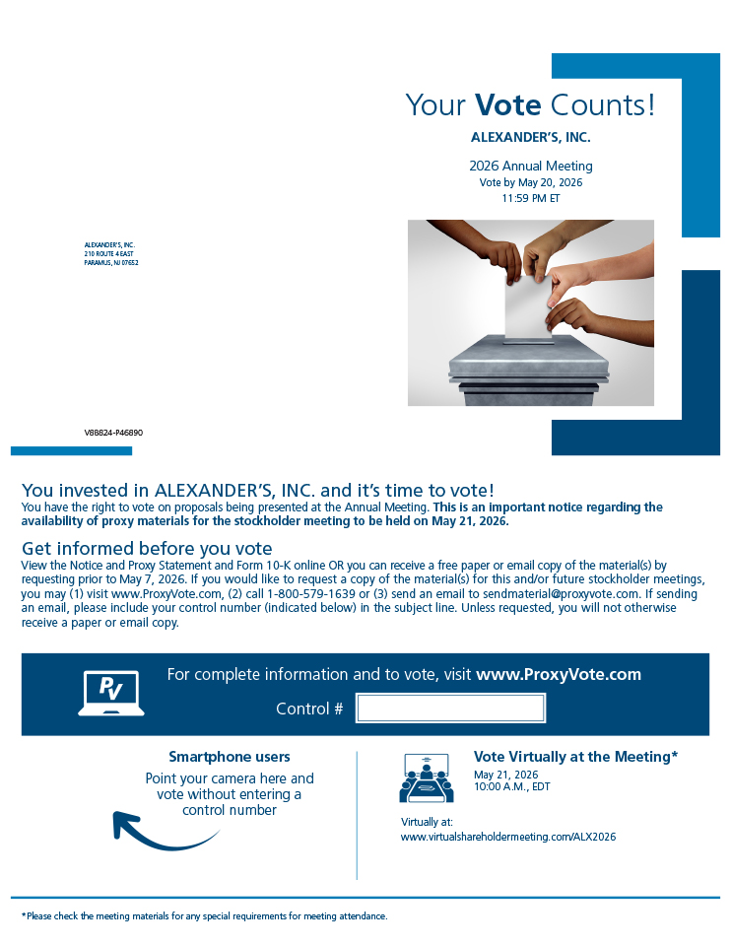
Your Vote Counts! *Please check the meeting materials for any special requirements for meeting attendance. Smartphone users Point your camera here and vote without entering a control number For complete information and to vote, visit www.ProxyVote.com Control # V88824-P46890 ALEXANDER’S, INC. 2026 Annual Meeting Vote by May 20, 2026 11:59 PM ET ALEXANDER’S, INC. 210 ROUTE 4 EAST PARAMUS, NJ 07652 You invested in ALEXANDER’S, INC. and it’s time to vote! You have the right to vote on proposals being presented at the Annual Meeting. This is an important notice regarding the availability of proxy materials for the stockholder meeting to be held on May 21, 2026. Vote Virtually at the Meeting* May 21, 2026 10:00 A.M., EDT Virtually at: www.virtualshareholdermeeting.com/ALX2026 Get informed before you vote View the Notice and Proxy Statement and Form 10-K online OR you can receive a free paper or email copy of the material(s) by requesting prior to May 7, 2026. If you would like to request a copy of the material(s) for this and/or future stockholder meetings, you may (1) visit www.ProxyVote.com, (2) call 1-800-579-1639 or (3) send an email to sendmaterial@proxyvote.com. If sending an email, please include your control number (indicated below) in the subject line. Unless requested, you will not otherwise receive a paper or email copy.

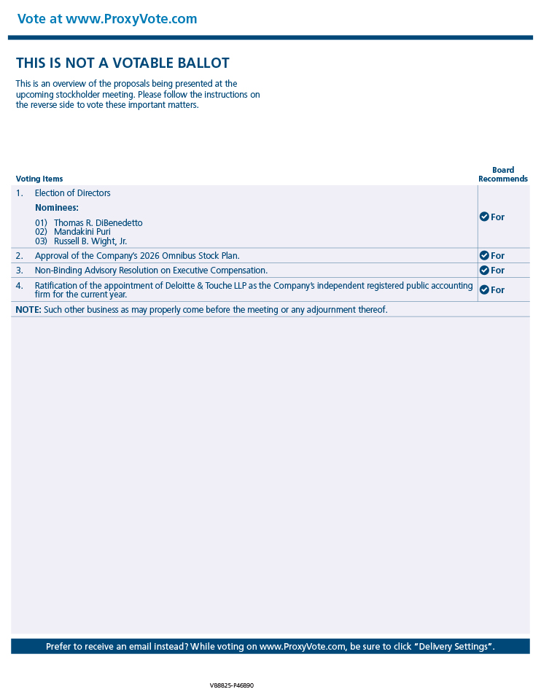
Vote at www.ProxyVote.com Prefer to receive an email instead? While voting on www.ProxyVote.com, be sure to click “Delivery Settings”. Voting Items Board Recommends V88825-P46890 THIS IS NOT A VOTABLE BALLOT This is an overview of the proposals being presented at the upcoming stockholder meeting. Please follow the instructions on the reverse side to vote these important matters. 1. Election of Directors For Nominees: 01) Thomas R. DiBenedetto 02) Mandakini Puri 03) Russell B. Wight, Jr. 2. Approval of the Company’s 2026 Omnibus Stock Plan. For 3. Non-Binding Advisory Resolution on Executive Compensation. For 4. Ratification of the appointment of Deloitte & Touche LLP as the Company’s independent registered public accounting firm for the current year. For NOTE: Such other business as may properly come before the meeting or any adjournment thereof.

